**Name : Aarya Tiwari**

**Batch : B2:**

**Roll No. : 16010421119**

**Course: UI Programming**

**Experiment No. : 7**

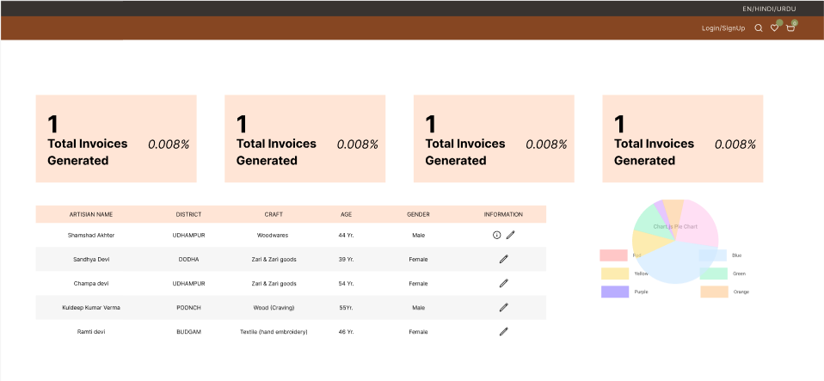

A well-designed dashboard for your ODOP (One District, One Product) initiative in Jammu and Kashmir, which provides an E-Marketplace, marketing benefits, and supply chain solutions for artisans, is a critical component of your product. The dashboard should offer a user-friendly, informative, and efficient experience for both artisans and administrators. Here's a description of the dashboard:

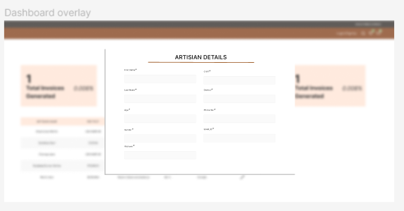

1. **Artisan Portal:**

Artisan Profiles: Artisans can manage their profiles, showcasing their craftsmanship, products, and stories.

E-Marketplace: Access to a user-friendly marketplace where artisans can list, update, and sell their products to a global audience.

Order Management: Monitor orders, track sales, and receive payments seamlessly.

1. **Marketing Resources:**

Marketing Insights: Marketing professionals can access data and insights to create targeted campaigns, helping artisans reach their intended audience.

Content Creation Tools: Generate engaging content, such as product descriptions and images, to effectively market artisan products.

1. **Supply Chain Management:**

Inventory Management: Artisans and logistics managers can monitor product availability, helping maintain stock levels efficiently.

Order Fulfillment: Track orders, manage shipping, and optimize delivery routes for timely and cost-effective delivery.

1. **Performance Analytics:**

Key Metrics: Provide detailed analytics on sales, customer engagement, and marketing performance, enabling informed decisions.

Custom Reports: Generate custom reports and dashboards to assess the impact of the initiative on the local economy.

1. **User Support and Assistance:**

Help Center: Offer a dedicated support center with resources, FAQs, and contact options to assist users.

Live Chat: Provide real-time assistance for immediate inquiries and troubleshooting.

1. **Administrative Tools:**

Program Coordination: Program coordinators and administrators can oversee the initiative, access aggregated data, and make strategic decisions based on performance insights.

User Management: Admins can manage user accounts, permissions, and roles within the system.

**Design Aesthetics:**

The ODOP Dashboard features a clean, intuitive, and responsive design. It incorporates the cultural elements of Jammu and Kashmir to connect with the rich heritage of the region. The color palette reflects the vibrancy of the handicrafts, while clear typography and well-organized layouts ensure ease of use.

**User-Centered Approach:**

The dashboard is designed with a user-centric approach, ensuring that it is accessible, easy to navigate, and provides actionable insights for both artisans and professionals involved in marketing and logistics. User feedback and usability testing have been integral in shaping its design.

**Outcomes:**

CO2: Apply principles of information organization and navigation along with data handling in web interface design

**Conclusion:**

We can conclude that we have learnt to build a dashboard.